1)USE CASE DIAGRAM

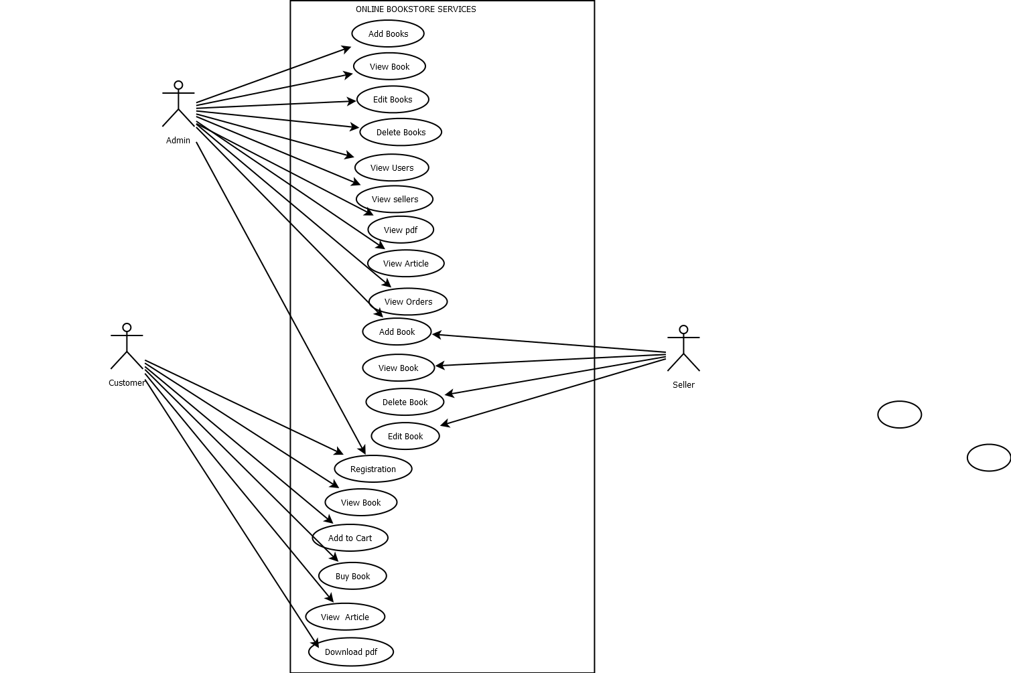

2)CLASS DIAGRAM

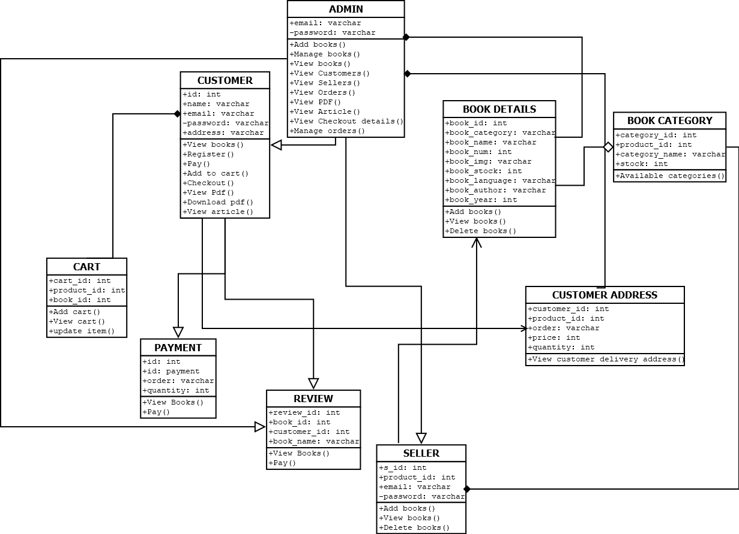

3)SEQUENCE DIAGRAM

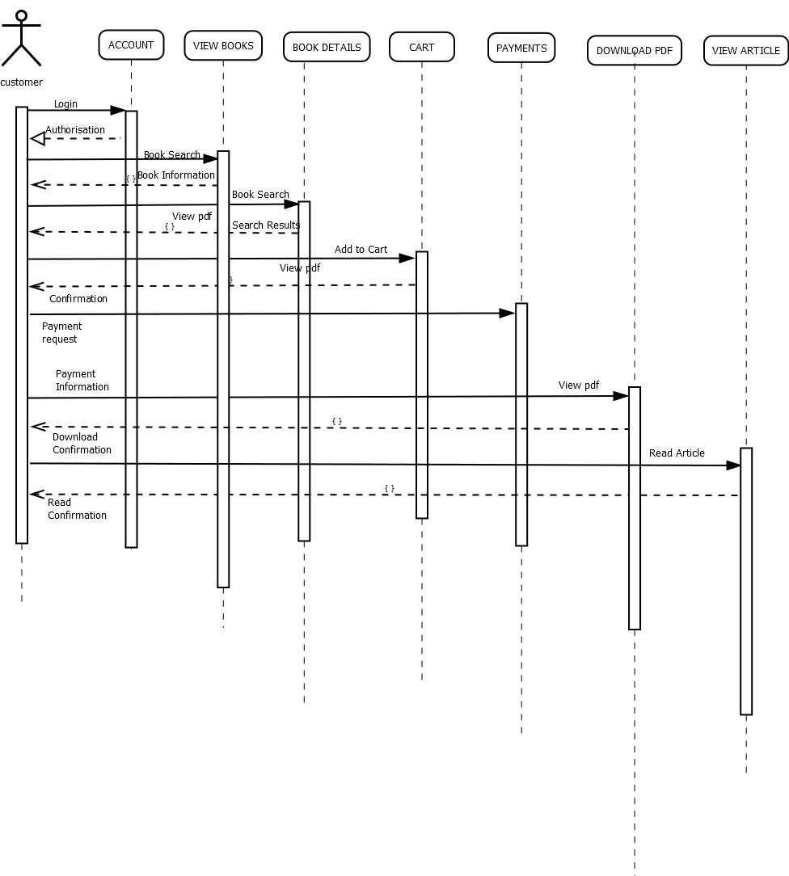

4)STATE CHART DIAGRAM

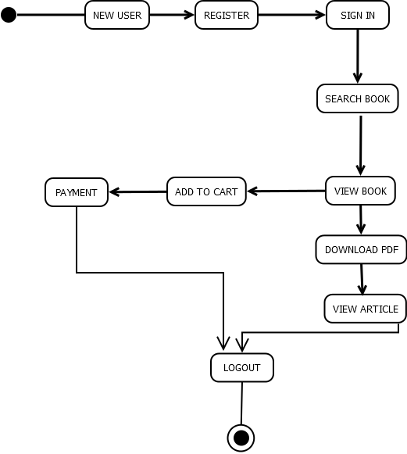

5)ACTIVITY DIAGRAM

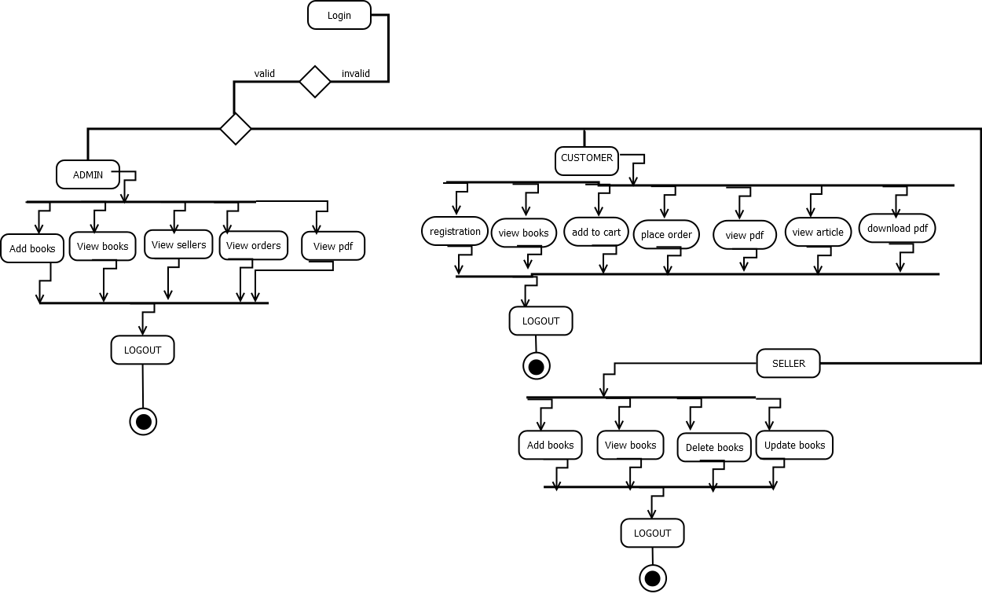

6)OBJECT DIAGRAM

